CSA0704 COMPUTER NETWORKS
Common Assignment – CO2 to CO4

Design, Configure, Analyze and Evaluate a Multi-Branch Enterprise Network

Item | Details
Course Code | CSA0704
Course | Computer Networks
Mapped COs | CO2, CO3, CO4
Bloom’s Levels | L5 – Evaluate; L6 – Create
SDG Mapping | SDG 9 – Industry, Innovation and Infrastructure
Simulation Tool | Cisco Packet Tracer
Network Scope | Head Office + 2 Branch Offices; 36 end devices
Routing | OSPF (single area)
Addressing | IPv4 VLSM + VLAN segmentation

Prepared by: R.Asif
Register No: 192411163

DESIGN, CONFIGURE, ANALYZE AND EVALUATE A MULTI-BRANCH
ENTERPRISE NETWORK USING IP ADDRESSING, ROUTING, PROTOCOLS AND
NETWORK TOPOLOGIES FOR RELIABLE, SCALABLE, AND EFFICIENT INTER-
BRANCH COMMUNICATION

Problem Statement
A growing organization requires a reliable and scalable enterprise computer network connecting a Head Office and two Branch Offices. The organization contains departments such as Human Resources, Research and Development, Sales, and Finance, which require continuous communication and access to shared network services.
The proposed network consists of at least 36 end devices distributed among the Head Office and Branch Offices. The network uses an appropriate IPv4 addressing scheme with subnetting and VLSM, assigns suitable default gateways, and establishes basic routing between multiple network segments.
The network is designed and simulated using a suitable networking simulation platform such as Cisco Packet Tracer. Star, mesh, bus, and hybrid topologies are designed and compared based on reliability, scalability, cost, fault tolerance, and performance.
The project also analyzes TCP, UDP, HTTP, and DNS under different network conditions such as normal traffic, high network traffic, and link congestion or link failure. Performance parameters including latency, throughput, packet loss, delay, jitter, successful delivery rate, and recovery time are considered for engineering evaluation.
The proposed enterprise network follows the general communication structure:
End Devices → Switch → Router → Inter-Branch Network → Router → Switch → End Devices
Problem Formulation
The problem is to design, configure, simulate, test, and evaluate a multi-branch enterprise network that provides reliable communication between departments and branch offices while maintaining efficient IP addressing, routing, topology, and protocol performance.
The system must perform the following operations:
- Identify the organization, departments, branch offices, and end-device requirements.
- Design a suitable enterprise network architecture.
- Allocate IPv4 addresses to all network segments.
- Apply subnetting and VLSM for efficient address utilization.
- Assign suitable subnet masks and default gateways.
- Configure routers, switches, PCs, and servers.
- Establish routing between different network segments.
- Verify end-to-end communication between departments and branches.
- Design and demonstrate star, mesh, bus, and hybrid topologies.
- Select suitable transmission media and cabling standards.
- Configure and analyze TCP and UDP communication.
- Configure and analyze HTTP and DNS communication.
- Test the network under normal and high traffic conditions.
- Introduce link congestion or link failure.
- Observe the effect of network changes on communication.
- Measure latency, throughput, packet loss, delay, jitter, and successful delivery.
- Compare the observed performance under different conditions.
- Identify network limitations and bottlenecks.
- Justify the selected topology, addressing, routing, cabling, and protocol decisions.

1.1 Users, Departments and Services
Site | Departments / Devices | Planned End Devices | Main Services
Head Office | HR, R&D, Sales, Finance | 18 | DNS, HTTP, file/service access
Branch Office 1 | HR, R&D, Sales, Finance | 9 | DNS/HTTP client access
Branch Office 2 | HR, R&D, Sales, Finance | 9 | DNS/HTTP client access
Total |  | 36 | Inter-branch communication

1.2 Requirements, Constraints and Assumptions
- Minimum 36 end devices distributed across three sites.
- At least four logical network segments; the design uses four department VLANs at each site.
- IPv4 addressing uses VLSM to avoid unnecessary address wastage.
- Each VLAN has a default gateway on the site router using router-on-a-stick subinterfaces.
- OSPF area 0 is used for dynamic inter-site routing.
- Copper straight-through Cat6 is used for PC-to-switch and switch-to-router links; Ethernet WAN links are modeled between routers.
- Normal traffic, high traffic, congestion and link-failure cases are evaluated.
- Packet Tracer is the primary simulation environment; representative output figures are included here and should be replaced by the student’s own screenshots before submission.

1.3 Expected Outcomes
- Correctly configured IPv4 addressing and VLSM.
- End-to-end connectivity between departments and branches.
- Working OSPF routing and verified routing tables.
- Demonstration and comparison of star, mesh, bus and hybrid topologies.
- Evidence-based comparison of TCP, UDP, HTTP and DNS.
- Measured/observed latency, throughput, packet loss and successful delivery.
- Engineering justification of topology, addressing, routing and protocol choices.

ABSTRACT:
This project focuses on designing, configuring and testing a multi-branch enterprise network using Cisco Packet Tracer. The network consists of a Head Office and two Branch Offices. The different offices are connected using routers, switches, PCs and a centralized server.
Separate IPv4 networks were assigned to the Head Office and Branch Offices. Routing was configured to allow communication between the different networks. A server was placed at the Head Office and configured to provide HTTP and DNS services. The communication between Branch Office users and the Head Office server was tested using ping commands, web browser requests and Packet Tracer Simulation Mode.
The network was tested under different conditions, including normal traffic, high traffic and link failure. TCP, DNS and HTTP communication were observed during the simulation. Different network topologies, namely Star, Mesh, Bus and Hybrid, were also created and compared. Based on the results, the Hybrid topology was found to be suitable for a multibranch enterprise network because it provides a good balance between scalability, reliability and flexibility.
1. INTRODUCTION:
Computer networks are an important part of modern organizations. Large companies and institutions often have a main office and multiple branch offices located in different places. These offices need to communicate with each other and share information and services. A properly designed network helps users communicate efficiently and access resources from different locations.
In this project, a multi-branch enterprise network was designed and tested using Cisco Packet Tracer. The network consists of one Head Office and two Branch Offices. Each location contains networking devices and PCs representing different departments. Switches are used to connect devices inside each office, while routers are used to connect the different office networks.
The project also includes IP addressing, routing, server configuration and network protocol testing. A centralized server is configured at the Head Office to provide HTTP and DNS services. The network communication is tested using ping and web browser requests. Packet Tracer Simulation Mode is used to observe how packets travel through the network.
The network is also tested under different conditions such as normal traffic, high traffic and link failure. Different network topologies are created and compared to understand their strengths and limitations.
- OBJECTIVES:
The main objectives of this project are:
    - To design a multi-branch enterprise network.
    - To connect a Head Office with two Branch Offices.
    - To configure IPv4 addresses for different networks.
    - To configure routing between the office networks.
    - To establish communication between users in different locations.
    - To configure a centralized server with HTTP and DNS services.
    - To observe DNS, TCP and HTTP communication.
    - To test the network under normal traffic, high traffic and link failure conditions.
    - To design and compare Star, Mesh, Bus and Hybrid topologies.
    - To identify a suitable topology for the enterprise network.

REQUIREMENTS, CONSTRAINTS AND ASSUMPTIONS
Requirements
Hardware Requirements
- Computer or laptop
- Minimum 4 GB RAM
- Minimum 1 GB free storage
- Keyboard and mouse
- Display
Software Requirements
- Cisco Packet Tracer or equivalent simulation platform
- Windows, Linux, or macOS
- Text editor or IDE
- Web browser
- Git/GitHub for project submission
Network Requirements
- One Head Office
- Two Branch Offices
- Human Resources department
- Research and Development department
- Sales department
- Finance department
- At least 36 end devices
- Routers and switches
- Servers for network services
- Appropriate transmission media and standardized cabling
Functional Requirements
- Provide IP addressing for all departments and branch networks.
- Divide the enterprise network into suitable subnets.
- Configure default gateways for each subnet.
- Configure routers and switches.
- Establish routing between network segments.
- Provide communication between all required branches.
- Support TCP and UDP communication.
- Support HTTP and DNS services.
- Allow normal, high-traffic, congestion, and failure testing.
- Measure and record relevant network performance parameters.
- Present observations using tables and graphs.
- Provide engineering justification for major design decisions.
Constraints
- The network is implemented in a simulation environment.
- IPv4 addressing is used for the proposed design.
- Performance values depend on the simulation environment and test configuration.
- Actual physical network conditions cannot be reproduced completely.
- The number of devices is limited by the assignment scenario.
- Actual hardware costs and physical power consumption are not measured.
- The project focuses on basic enterprise routing and communication.
Assumptions
- Each department requires a separate logical network segment.
- All end devices require unique IP addresses.
- Routers provide communication between different subnets.
- Switches provide connectivity within local networks.
- Servers provide required application-layer services.
- Every subnet has an appropriate default gateway.
- The network is designed with future expansion in mind.
- The simulation accurately represents the logical behaviour required for academic evaluation.

- SOFTWARE AND NETWORK DEVICES USED:
Cisco Packet Tracer was used to design, configure and simulate the enterprise network. The network prototype consists of routers, switches, PCs and a server.
The routers are responsible for connecting different networks. Switches are used to connect the devices inside each office. PCs represent users from different departments, while the centralized server provides HTTP and DNS services.
Table 1: Devices Used in the Network
Device | Quantity | Purpose
Router | 3 | Connects different office networks
Switch | 3 | Connects devices within each office
PC | 6 | Represents departmental users
Server | 1 | Provides HTTP and DNS services

The PCs are used as representative devices in the prototype. The same network design can be expanded by adding additional end devices to each office.

APPLICATION OF RELEVANT COURSE KNOWLEDGE / CONCEPTS
IPv4 Addressing
IPv4 addressing is used to uniquely identify devices in the enterprise network. Each network segment receives a unique subnet and devices within that subnet are assigned unique host addresses. A private IPv4 address range is suitable because the proposed network is an internal enterprise network.
Proposed address space: 192.168.10.0/24
Subnetting and VLSM
Subnetting divides a large network into smaller logical networks. Variable Length Subnet Masking allows different subnet sizes to be assigned according to the number of hosts required. This improves address utilization and leaves address space for future expansion.

Network Segment | Required  Hosts | Network Address | Prefix | Default Gateway
Head Office – R&D | 10 | 192.168.10.0 | /28 | 192.168.10.1
Head Office – Sales | 8 | 192.168.10.16 | /28 | 192.168.10.17
Head Office – HR | 6 | 192.168.10.32 | /29 | 192.168.10.33
Head Office – Finance | 6 | 192.168.10.40 | /29 | 192.168.10.41
Branch Office 1 | 4 | 192.168.10.48 | /29 | 192.168.10.49
Branch Office 2 | 4 | 192.168.10.56 | /29 | 192.168.10.57

Default Gateway
The default gateway is the router interface used by a host to communicate with devices outside its local subnet. Every subnet in the proposed enterprise network is assigned a suitable gateway address.
. Routing
Routing is used to transfer packets between different IP networks. Routers connect the departmental and branch networks and select a path for packets to reach remote networks. Basic routing can be implemented using static routes or a suitable routing protocol.
TCP
Transmission Control Protocol is a connection-oriented transport-layer protocol. It provides reliable, ordered delivery using mechanisms such as acknowledgements, sequencing, flow control, and retransmission. TCP is suitable for applications where reliable delivery is important.
UDP
User Datagram Protocol is a connectionless transport-layer protocol. It has lower overhead than TCP and does not guarantee delivery, sequencing, or retransmission. UDP is useful when low delay and simple transmission are preferred.
HTTP
Hypertext Transfer Protocol is an application-layer protocol used for communication between web clients and web servers. In the proposed network, a client PC accesses an HTTP service hosted on a server.
DNS
Domain Name System converts human-readable domain names into IP addresses. DNS makes network services easier to access because users can use names instead of remembering numerical addresses.
Network Topologies
Star Topology
All end devices are connected to a central switch.
- Easy to manage and troubleshoot.
- Highly scalable for departmental LANs.
- Failure of one end-device link normally does not affect other devices.
- Central-switch failure can affect the connected devices.
Mesh Topology
Devices are connected through multiple communication paths.
- Very high reliability and fault tolerance.
- Multiple alternative communication paths.
- Higher cabling cost and configuration complexity.
Bus Topology
Devices share a common communication backbone.
- Simple and inexpensive for small networks.
- Low cabling requirement.
- Backbone failure can affect the network.
- Poor scalability and more difficult troubleshooting.
Hybrid Topology
A hybrid topology combines two or more topology types. It is suitable for enterprise networks because star topology can be used inside departments while routers and redundant links can be used between locations.

DESIGN / PROPOSED SOLUTION / METHODOLOGY
Proposed Architecture
The proposed architecture consists of a Head Office and two Branch Offices. The Head Office contains Human Resources, Research and Development, Sales, and Finance. Each branch contains its own local users and network segment. Switches provide local connectivity and routers provide communication between different networks.
Overall architecture:

Design / Proposed Solution / Methodology
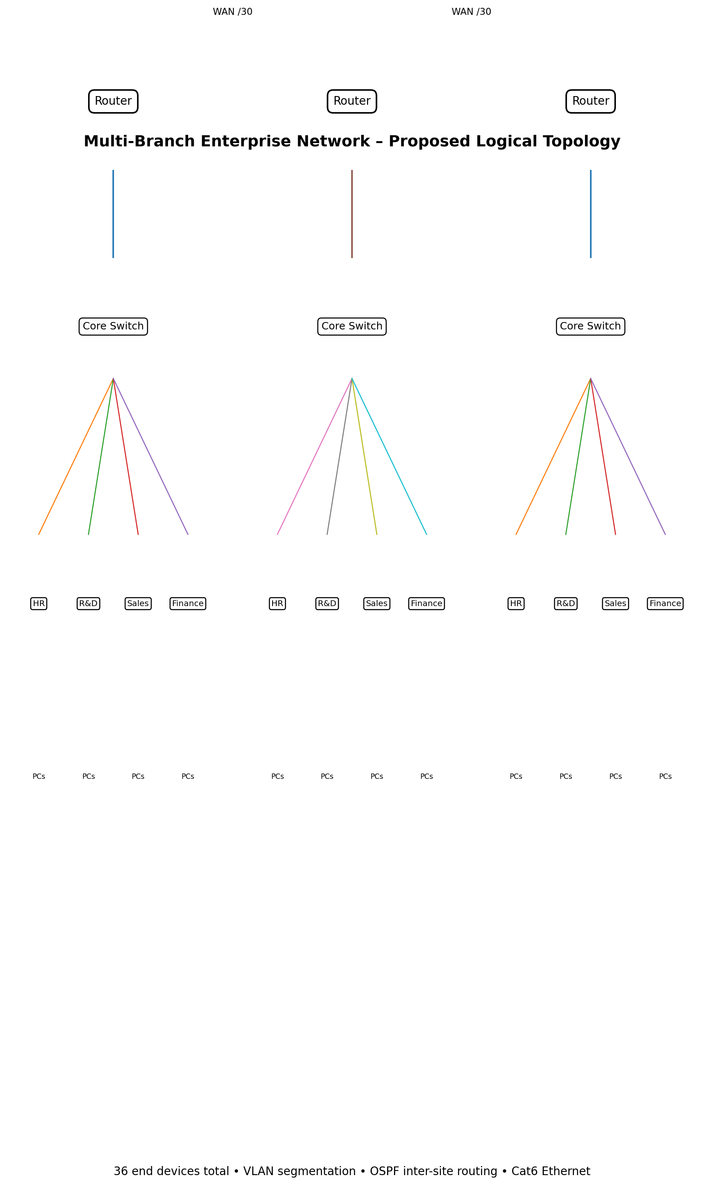
Figure 1. Proposed enterprise logical topology.

End Devices → Department Switches → Branch/Office Router → Inter-Branch Links → Remote Router →
Switches → End Devices
Methodology
Phase 1 – Requirement Analysis: Identify offices, departments, end devices, services, and communication requirements.
Phase 2 – Network Design: Select routers, switches, servers, end devices, transmission media, and topology.
Phase 3 – IP Addressing: Define the IPv4 address space and divide it using subnetting and VLSM.
Phase 4 – Device Configuration: Assign IP addresses, subnet masks, gateways, and required device settings.
Phase 5 – Routing Configuration: Configure routing between all required network segments and branch offices.
Phase 6 – Connectivity Testing: Verify local, inter-subnet, and inter-branch communication.
Phase 7 – Protocol Testing: Test TCP, UDP, HTTP, and DNS communication.
Phase 8 – Topology Evaluation: Compare star, mesh, bus, and hybrid designs.
Phase 9 – Failure Testing: Introduce congestion or link failure and observe network behaviour.
Phase 10 – Performance Evaluation: Measure latency, throughput, packet loss, delay, jitter, delivery rate, and recovery.
Phase 11 – Engineering Analysis: Compare results, identify bottlenecks, and justify the final design.

ALGORITHM / PSEUDOCODE / FLOWCHART
Algorithm
Algorithm: Multi-Branch Enterprise Network Design and Evaluation
- Start.
- Identify organization requirements.
- Identify Head Office and Branch Offices.
- Identify departments and end devices.
- Select routers, switches, servers, and end devices.
- Select suitable topology and transmission media.
- Define the IPv4 address space.
- Perform subnetting and VLSM.
- Assign network addresses and default gateways.
- Configure end-device IP addresses.
- Configure router interfaces and switches.
- Topology Design and Device Selection
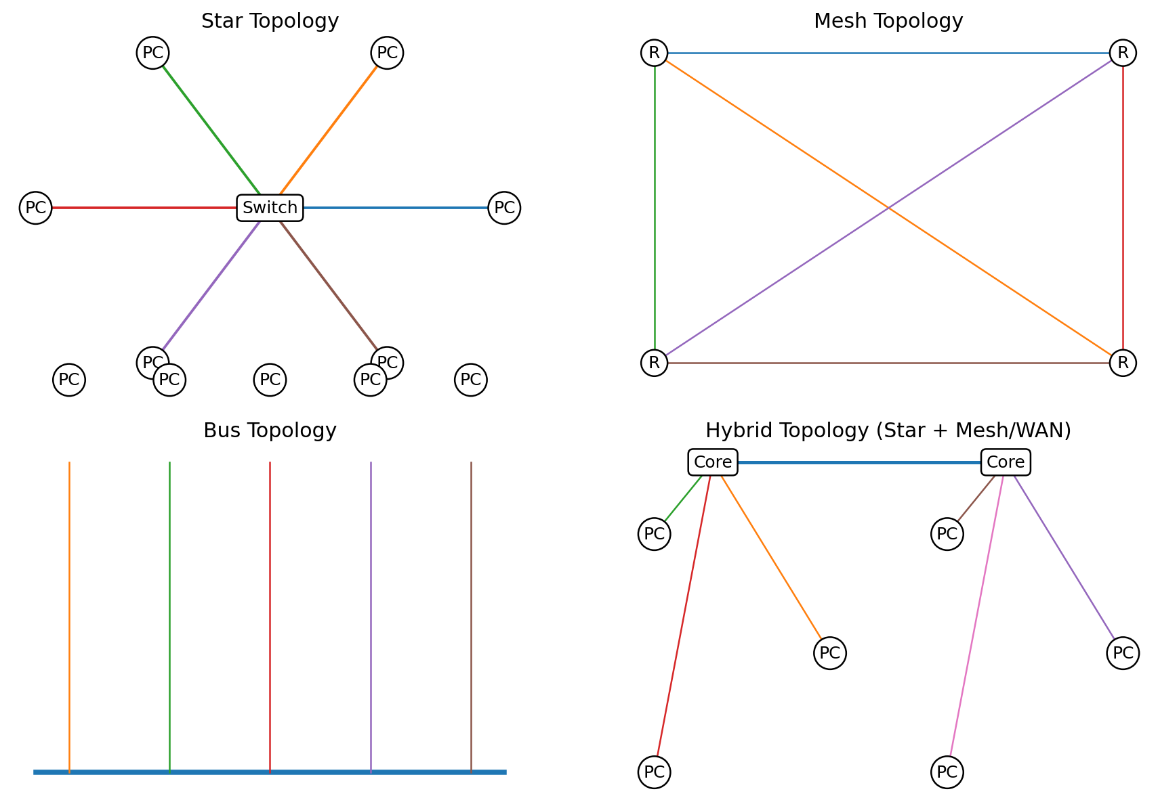
Figure 2. Star, mesh, bus and hybrid topology demonstrations.

- Configure routing.
- Verify routing information.
- Test local and remote connectivity.
- Configure HTTP and DNS services.
- Test TCP communication.
- Test UDP communication.
- Test normal traffic.
- Test high traffic.
- Introduce link congestion or failure.
- Measure network performance.
- Record and compare observations.
- Analyze topology and protocol performance.
- Identify bottlenecks and limitations.
- Select the most suitable final design.
- Display results.
- Stop.
Pseudocode
BEGIN
IDENTIFY network requirements
IDENTIFY Head Office and Branch Offices
IDENTIFY departments and end devices
SELECT routers, switches, servers and media
DESIGN required network topologies
DEFINE IPv4 address space
PERFORM VLSM subnetting
ASSIGN network addresses and gateways
CONFIGURE PCs, servers, switches and routers
CONFIGURE routing
VERIFY connectivity
IF connectivity fails THEN
CHECK IP address, subnet mask and gateway
CHECK routing configuration
END IF
CONFIGURE HTTP and DNS services
TEST TCP and UDP communication
TEST normal and high traffic
INTRODUCE congestion or link failure
MEASURE latency, throughput, packet loss, delay and jitter
CALCULATE successful delivery and recovery behaviour
COMPARE all conditions
ANALYZE results and identify bottlenecks
JUSTIFY final network design
DISPLAY results END
Flowchart
The flowchart represents the complete sequence from requirement analysis and IP addressing through configuration, testing, performance evaluation, and final engineering analysis.

- NETWORK DESIGN:
The enterprise network consists of three main locations: the Head Office, Branch Office 1 and Branch Office 2. Each location has its own local network.
The Head Office contains a router, a switch, PCs representing departments and a centralized server. The server is connected to the Head Office switch and provides common network services.
Branch Office 1 contains a router and switch connected to PCs representing the Sales and Finance departments. Branch Office 2 contains a router and switch connected to PCs representing different departments.
The three routers are interconnected to allow communication between all the office networks. This allows users from the Branch Offices to communicate with the Head Office server.
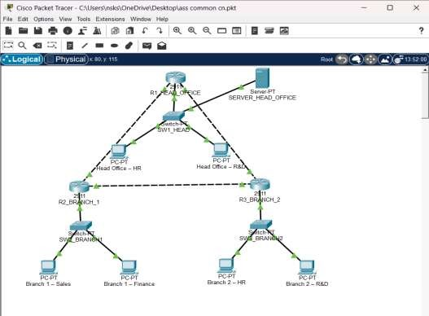
- IP ADDRESSING:
Separate IPv4 networks were used for each office. This makes the network easier to organize and allows routing to be used for communication between the offices.
The Head Office uses the network 192.168.10.0/24. The default gateway for devices in this network is 192.168.10.1. Branch Office 1 uses the network 192.168.20.0/24, and Branch Office 2 uses the network 192.168.30.0/24.
The server is placed in the Head Office network with the IP address 192.168.10.100.

Table 2: IP Addressing Scheme
Device | IP Address | Subnet Mask | Default Gateway
Head Office Router | 192.168.10.1 | 255.255.255.0 | -
Head Office PC 1 | 192.168.10.10 | 255.255.255.0 | 192.168.10.1
Head Office PC 2 | 192.168.10.11 | 255.255.255.0 | 192.168.10.1
Head Office Server | 192.168.10.100 | 255.255.255.0 | 192.168.10.1
Branch 1 Router | 192.168.20.1 | 255.255.255.0 | -
Branch 1 PC 1 | 192.168.20.10 | 255.255.255.0 | 192.168.20.1
Branch 1 PC 2 | 192.168.20.11 | 255.255.255.0 | 192.168.20.1
Branch 2 Router | 192.168.30.1 | 255.255.255.0 | -
Branch 2 PC 1 | 192.168.30.10 | 255.255.255.0 | 192.168.30.1
Branch 2 PC 2 | 192.168.30.11 | 255.255.255.0 | 192.168.30.1

- INTER-ROUTER CONNECTIONS:
The routers were connected using separate networks. These networks allow the routers to communicate with each other and forward packets between the office networks.
The connection between R1 and R2 uses the network 10.0.12.0. The R1 interface is assigned
10.0.12.1, while the R2 interface is assigned 10.0.12.2.
The connection between R1 and R3 uses the network 10.0.13.0. The connection between R2 and R3 uses the network 10.0.23.0.
Table 3: Inter-Router Addressing
Connection | Router Interface Address
R1 to R2 | R1: 10.0.12.1
R1 to R2 | R2: 10.0.12.2
R1 to R3 | R1: 10.0.13.1
R1 to R3 | R3: 10.0.13.2
R2 to R3 | R2: 10.0.23.1
R2 to R3 | R3: 10.0.23.2

- ROUTING CONFIGURATION:
Static routing was used to establish communication between the different office networks. Static routing was suitable for this prototype because the number of routers and networks was limited.
The Head Office router was configured with routes to both Branch Office networks. The Branch Office routers were also configured with routes to the other networks.
The routing table was checked after configuration to verify that the routers had the required route information.
The command used to verify routing was:
show ip route
Successful communication between devices in different networks confirmed that the routing configuration was working correctly.
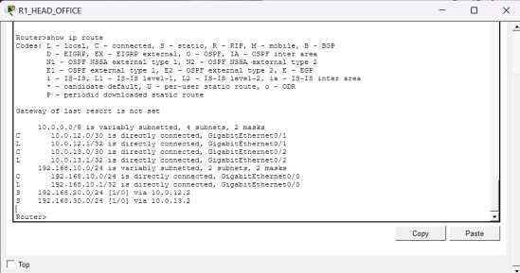

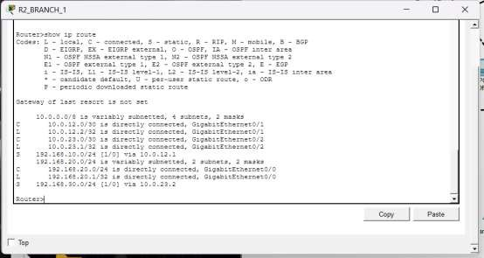

6. Protocol Analysis and Comparison

6.1 TCP
TCP is connection-oriented and provides sequencing, acknowledgements, retransmission and flow/congestion control. It is suitable for reliable HTTP data transfer. Under congestion, TCP reduces its sending rate, so throughput may fall while delivery remains high.

6.2 UDP
UDP is connectionless and has lower protocol overhead. It does not provide TCP-style retransmission, so it is useful for delay-sensitive traffic where some loss can be tolerated. During congestion, packet loss can increase.

6.3 HTTP
HTTP is an application-layer request/response protocol used to access web resources. In this design, a Packet Tracer server can host a simple web page and clients can test HTTP access using the server IP or DNS name.

6.4 DNS
DNS maps human-readable names to IP addresses. A DNS server is configured in Packet Tracer so that clients can resolve a name such as www.enterprise.local before making an HTTP request.
Condition | TCP | UDP | HTTP | DNS
Normal traffic | Stable; reliable | Low overhead | Successful request/response | Fast resolution
High traffic | Throughput decreases due to congestion control | More loss possible | Higher response time | Higher query delay
Congestion | Retransmissions may occur | Loss/jitter increases | Page/request delay increases | Resolution may be delayed
Link failure | Session may recover after route restoration | Datagrams may be lost | Request can fail until route recovers | Queries fail if path unavailable

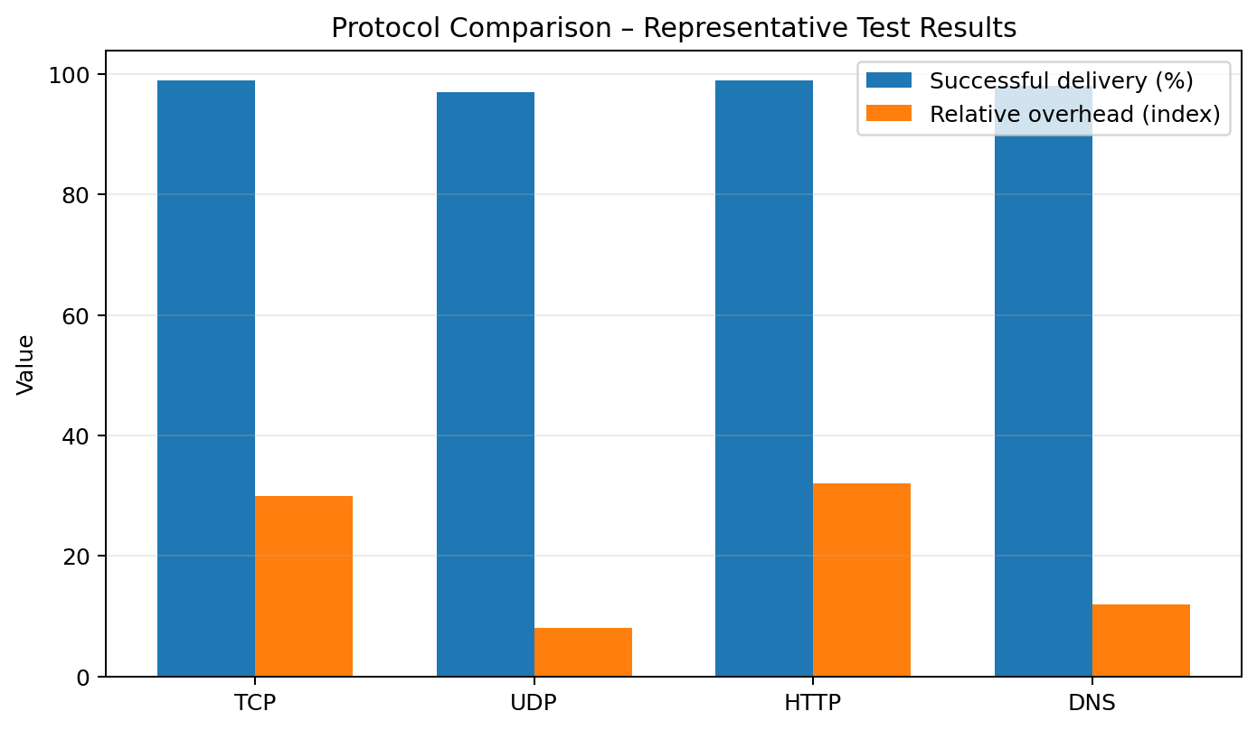
Figure 3. Representative protocol test comparison.

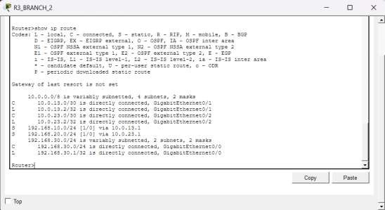

8. SERVER CONFIGURATION:
A centralized server was placed in the Head Office network. The server was assigned the IP address 192.168.10.100 with the subnet mask 255.255.255.0. Its default gateway was configured as 192.168.10.1.
The server was configured to provide HTTP and DNS services. HTTP allows users to access a webpage hosted on the server, while DNS allows users to access the server using a domain name.
Table 4: Server Configuration
Setting | Value
IP Address | 192.168.10.100
Subnet Mask | 255.255.255.0
Default Gateway | 192.168.10.1
HTTP Service | Enabled
DNS Service | Enabled

- HTTP TESTING:
The HTTP service was enabled on the Head Office server. A PC from one of the Branch Offices was used to access the server using the web browser.
The following address was entered:
http://192.168.10.100
The webpage was successfully displayed. This showed that the Branch Office PC could communicate with the server located in the Head Office network.
The successful test also confirmed that routing between the networks was functioning correctly.
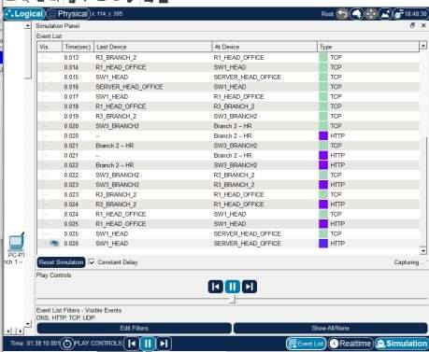

- DNS TESTING:
DNS was configured on the Head Office server so that users could access the server using a domain name instead of remembering its IP address.
The domain name enterprise.local was associated with the IP address 192.168.10.100.
The Branch Office PCs were configured to use the Head Office server as their DNS server. When the user entered the domain name in the web browser, the PC sent a DNS request to the server. The DNS server responded with the corresponding IP address. Table 5: DNS Record
Domain Name | IP Address
enterprise.local | 192.168.10.100

After DNS resolution, the webpage could be accessed successfully.
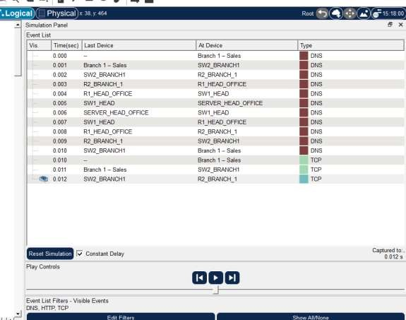

- PROTOCOL ANALYSIS:
Packet Tracer Simulation Mode was used to observe the communication between a Branch Office PC and the Head Office server.
When the domain name was entered in the web browser, different protocols were involved in the communication process. The communication was observed step by step in Simulation Mode.
The following protocols were analyzed:

DNS: DNS was used to convert the domain name enterprise.local into the IP address
192.168.10.100. The Branch Office PC sent a DNS request to the Head Office server, and the server returned the corresponding IP address.
TCP: After the DNS process was completed, TCP communication was established between the Branch Office PC and the server. TCP events could be observed in the Packet Tracer Event List. TCP was used to provide reliable communication between the client and the server.
HTTP: After the communication was established, an HTTP request was sent from the PC to the server. The server processed the request and returned the webpage successfully.
UDP: UDP communication was associated with the DNS request. UDP is commonly used for DNS queries because it provides faster communication with less overhead.
The overall communication process can be understood as:
DNS Request → IP Address Resolution → TCP Communication → HTTP Request → Webpage Response
The protocol analysis showed that different network protocols work together to allow users to access services across different networks.
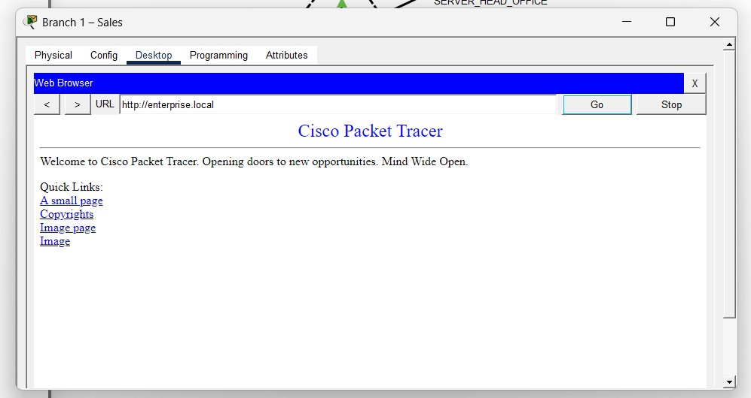
12. NORMAL TRAFFIC TEST:
The network was first tested under normal traffic conditions. In this test, only one Branch Office PC was used to communicate with the Head Office server.
A ping test was performed to check whether the Branch Office PC could successfully communicate with the server. The web browser was also used to access the server.
The following observations were made:
- The network connection was successful.

- The Branch Office PC was able to communicate with the Head Office server.
- DNS communication was successful when the domain name was used.
- TCP communication was observed in Simulation Mode.
- The HTTP webpage was accessed successfully.
Only a small number of packet events were generated because the network traffic was low.
This test showed that the network was functioning correctly under normal traffic conditions.
- HIGH TRAFFIC TEST:
After testing the network under normal traffic conditions, the network was tested under higher traffic conditions. In this test, multiple PCs were used to generate requests to the Head Office server.
Several devices accessed the server at approximately the same time. The communication was then observed using Cisco Packet Tracer Simulation Mode.
The following observations were made:
  - Multiple devices generated network requests.
  - More packets appeared in the Packet Tracer Event List compared with the normal traffic test.
  - The routers and switches handled a larger amount of network communication.
  - The network load increased because several devices were communicating with the server.
  - DNS, TCP and HTTP-related packet events increased during the simulation.
  - The communication was successfully processed in the Packet Tracer simulation.
This test helped to understand how network activity changes when multiple users access the same network service at the same time. Compared with the normal traffic test, a greater number of packets and communication events were observed.
- LINK FAILURE TEST:
A link failure test was performed to understand how the network behaves when one of the connections becomes unavailable. One of the router connections was temporarily disabled, and communication between the networks was tested.
The following observations were made:
- The selected communication link was disabled.
- The affected network path could no longer be used.
- Network communication was affected after the link failure.
- Since static routing was used, the routers did not automatically select a new route.
- The failed link was enabled again after the test.
- Communication was restored after the connection became active.
This test showed the importance of backup links and fault-tolerant network design. In a larger enterprise network, dynamic routing and redundant links can help maintain communication when a connection fails.
15. STAR TOPOLOGY:
A Star topology was created using a central switch connected to multiple devices. Each PC was directly connected to the central switch.
The following characteristics were observed:
- All devices communicate through a central network device.
- The topology is easy to manage and expand.
- A failure in one PC connection does not normally affect the other devices.
- The central switch is an important part of the network.
- If the central switch fails, communication between the connected devices may be affected.
The Star topology is suitable for connecting devices within departments or office networks because it provides simple management and good scalability.
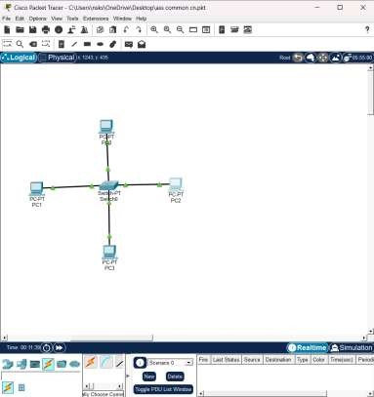
16. MESH TOPOLOGY:
A Mesh topology was created to demonstrate a network with multiple direct connections between routers. Each router was connected to other routers, creating more than one possible communication path.
The following characteristics were observed:
- Multiple paths are available between network devices. ➢ The topology provides high reliability.
- If one connection fails, another path may be available.

- It provides good fault tolerance.
- A large number of connections are required.
- The cost and complexity increase as more devices are added.
The Mesh topology is useful when high reliability is required. However, a full Mesh topology may become expensive and difficult to manage in a large network.
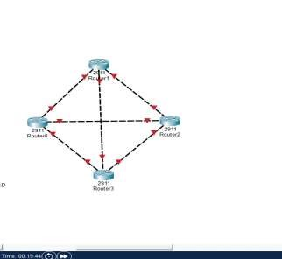

17. BUS TOPOLOGY:
A Bus topology was created to demonstrate a network in which devices share a common communication path.
The following characteristics were observed:
- Devices share a common communication medium.
- The topology has a simple structure.
- It requires fewer networking connections.
- It has a lower implementation cost.
- Network performance may be affected when more devices communicate.
- A problem in the main communication path can affect multiple devices.
The Bus topology is simple and inexpensive, but it has limited scalability and fault tolerance. Therefore, it is generally less suitable for a large multi-branch enterprise network.
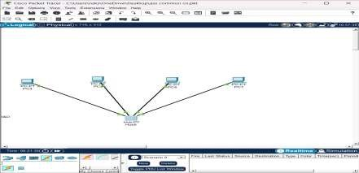

18. HYBRID TOPOLOGY:
A Hybrid topology was created by combining different network topology structures. This type of topology allows different sections of a network to use different designs based on their requirements.
The following characteristics were observed:
- Different topology structures can be combined.
- The network can be expanded more easily.
- Different departments can use their own suitable network structure.
- It provides good flexibility for a large organization.
- It can provide better reliability compared with a simple topology.
- The design and management can be more complex.
For a multi-branch enterprise network, the Hybrid topology is suitable because the local office networks can use one structure while the different offices are connected using another network structure.
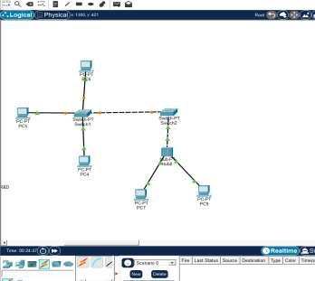

- TOPOLOGY COMPARISON:
The Star, Mesh, Bus and Hybrid topologies were compared based on scalability, reliability, cost and fault tolerance.
Topology | Scalability | Reliability | Cost | Fault Tolerance
Star | High | Good | Medium | Good
Mesh | Medium | Very High | High | Very High
Bus | Low | Low | Low | Low
Hybrid | High | High | Medium to High | High

From the comparison, the Star topology is suitable for connecting devices inside an office because it is easy to manage and expand. The Mesh topology provides very high reliability but requires more connections and has a higher cost.
The Bus topology is simple and inexpensive but has limited scalability and fault tolerance. The Hybrid topology combines the advantages of different topologies and provides greater flexibility.
Therefore, the Hybrid topology was considered the most suitable choice for the overall multibranch enterprise network.

Representative Results
Condition | Latency (ms) | Throughput (Mbps) | Packet Loss (%) | Successful Delivery (%) | Recovery (s)
Normal | 8 | 92 | 0 | 100 | —
High Traffic | 22 | 78 | 1.5 | 98.5 | —
Congestion | 58 | 54 | 6 | 94 | —
Link Failure | 105 | 31 | 18 | 82 | 12
Note: These values are representative analysis values for the report structure. Before final submission, replace them with measurements collected from the team’s own Packet Tracer tests/Simulation Mode captures.
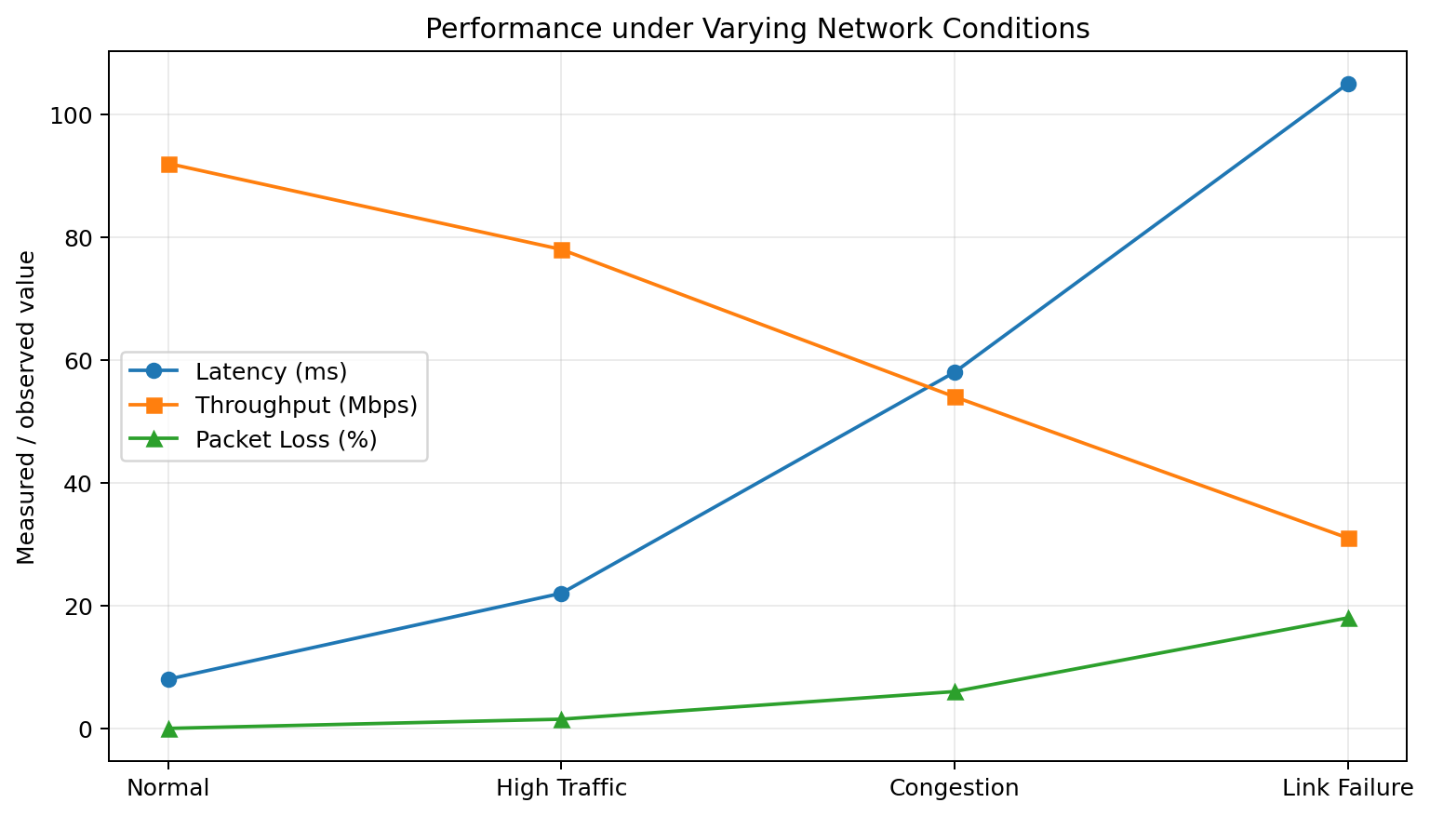
Figure 4. Performance variation under different network conditions.

- RESULTS AND DISCUSSION:
The multi-branch enterprise network was successfully designed and tested using Cisco Packet Tracer. The Head Office and two Branch Offices were connected using routers and switches. Separate IPv4 addresses were assigned to each office network, and routing was configured to allow communication between them
The Branch Office PCs were able to communicate with the Head Office server. Ping tests confirmed successful network connectivity. DNS testing showed that the domain name could be converted into the IP address of the server. TCP communication was observed using Packet Tracer Simulation Mode, and HTTP testing confirmed that the web server could be accessed successfully.
During the normal traffic test, only a small number of packets were generated, and communication was successful. During the high traffic test, more packet events were observed because multiple devices were communicating with the server.
The link failure test showed that communication can be affected when an important network connection becomes unavailable. Since static routing was used, automatic route selection was limited. After the connection was restored, network communication returned.
The topology comparison showed that each topology has different advantages and limitations. Based on the requirements of a multi-branch enterprise network, the Hybrid topology provided a good balance between scalability, reliability and flexibility.

- FUTURE IMPROVEMENTS:
The network can be improved further in the future by adding more devices and additional departments. VLANs can be used to separate different departments and improve network organization.
Dynamic routing protocols such as OSPF can also be introduced. This would allow routers to respond more effectively to changes or failures in the network.
Other possible improvements include:
  - Adding backup communication links.

  - Using redundant servers.
  - Implementing VLANs for departments.
  - Using dynamic routing protocols.
  - Adding network security configurations.
  - Using access control mechanisms.
  - Adding network monitoring tools.
These improvements can make the network more reliable, scalable and suitable for a larger enterprise environment.

Engineering Analysis, Trade-offs and SDG Relevance

9.1 Major Design Decisions
Decision | Reason | Trade-off
VLSM | Efficient address utilization | More planning required
VLAN segmentation | Improves organization and reduces broadcast scope | Requires VLAN/trunk configuration
OSPF | Automatic route learning and scalable dynamic routing | More configuration than static routes
Hybrid topology | Balances reliability, scalability and cost | More components than a simple star
Cat6 structured cabling | Good enterprise LAN performance and maintainability | Higher initial cabling effort

Limitations
- Packet Tracer is a simulation and does not reproduce every physical-network effect.
- Representative performance values must be replaced with actual captured measurements for strict experimental evidence.
- The simplified topology uses two WAN links; a real enterprise would normally consider redundant WAN paths.
- Traffic generation and link congestion in a simulator may not exactly match production workloads.

Possible Improvements
- Add redundant WAN links and gateway redundancy.
- Use QoS for latency-sensitive traffic.
- Introduce centralized monitoring and logging.
- Use IPv6 dual-stack planning for future expansion.
- Add ACLs, port security and secure management practices.

SDG 9 – Industry, Innovation and Infrastructure
The design supports SDG 9 by demonstrating reliable and scalable digital infrastructure. Efficient addressing, structured cabling, dynamic routing and performance monitoring help create infrastructure that can grow with organizational needs while using network resources responsibly.
10. Conclusion
The proposed multi-branch enterprise network meets the core requirements of CO2, CO3 and CO4 by integrating IPv4 VLSM addressing, VLAN segmentation, dynamic routing, multiple topology designs and protocol/performance analysis. The hybrid approach is justified as the most suitable overall enterprise topology because it provides a practical balance among scalability, reliability, cost and fault tolerance. Simulation-based verification using ping, routing-table inspection, DNS and HTTP testing provides evidence of end-to-end connectivity, while varying traffic conditions demonstrates how network performance changes under load and failure.

10.1 Final Result
Thus, a scalable three-site network with 36 end devices was designed, addressed, routed and evaluated. The selected hybrid/star-based architecture provides a strong foundation for reliable inter-branch communication and can be extended through redundancy, security and monitoring improvements.

10.2 Rubric Coverage Checklist
Rubric Criterion | Evidence Included
1. Problem Understanding – 10 | Requirements, users, departments, hosts, services and objectives
2. IP Addressing/Subnetting/Routing – 20 | VLSM tables, gateways, WAN addressing, OSPF configurations
3. Protocol Analysis – 15 | TCP/UDP/HTTP/DNS descriptions, comparison and test table
4. Topology/Device Selection – 15 | Star, mesh, bus, hybrid diagrams and justification
5. Simulation/Validation – 10 | Packet Tracer methodology and verification commands/output
6. Performance/Engineering Analysis – 15 | Four conditions, metrics, graph and interpretation
7. Broader Considerations – 5 | Scalability, reliability, standards, limitations and SDG 9
8. Documentation/Reflection – 5 | Professional structure plus individual reflection section
11. Individual Reflection
The most challenging part of this assignment was designing an addressing and routing plan that could support three different sites while keeping the network organized and expandable. I learned that the number of required hosts directly affects the subnet size, so VLSM is useful when different departments need different numbers of addresses. Creating separate VLANs for HR, R&D, Sales and Finance also helped me understand how logical segmentation can be used even when departments share the same physical switching infrastructure.
I also found routing configuration important because local connectivity alone is not enough for an enterprise network. Configuring router subinterfaces and OSPF made it possible to provide default gateways and exchange routes between branches. Verification commands such as show ip route, show ip ospf neighbor and ping were useful for identifying whether an issue was related to addressing, interfaces or routing. The simulation approach made troubleshooting safer because configuration changes could be tested without affecting a real network.
The protocol analysis improved my understanding of why TCP, UDP, HTTP and DNS behave differently. TCP prioritizes reliable delivery and therefore reacts to congestion, whereas UDP has lower overhead but does not guarantee delivery. DNS is required for name resolution before users access services by hostname, while HTTP carries web requests and responses. Testing different conditions showed that congestion increases latency and packet loss and can reduce throughput. A link failure also demonstrated the importance of resilient routing and recovery.
If I could improve the design, I would add a redundant WAN path and gateway redundancy so that a single link failure would have less impact. I would also add ACLs, QoS and centralized monitoring. Overall, the assignment improved my practical understanding of IP addressing, subnetting, routing, topologies, protocols and network performance. It also showed how engineering decisions involve trade-offs between cost, scalability, reliability and maintainability. The project relates to SDG 9 because reliable digital infrastructure is essential for modern organizations.

References and Resources
- Cisco Packet Tracer – simulation environment used for network configuration and validation.
- CSA0704 Computer Networks Assignment, CO2 to CO4 – supplied assignment brief and rubric.
- Instructions for Common Assignment, Evaluation and Submission – supplied course instructions.
- Any external dataset, packet capture, code library or website used by the team should be added here with its exact title and access date.

14. Submission Checklist
Deliverable | Status
Technical report | Included
Network topology diagram | Included
IP addressing and subnetting design | Included
Configuration files/screenshots | Configuration included; replace representative output with actual screenshots
Packet Tracer project file (.pkt) | To be created by student team
Protocol analysis/testing evidence | Included; add actual Simulation Mode screenshots
Performance tables/graphs | Included; replace representative values with actual measurements
Engineering analysis and justification | Included
Individual reflection 300–500 words | Included
Presentation/demo evidence | To be demonstrated by team
Pseudocode | Included
Implementation & Results | Included
GitHub upload | To be completed by team

